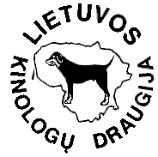
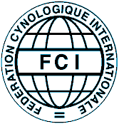
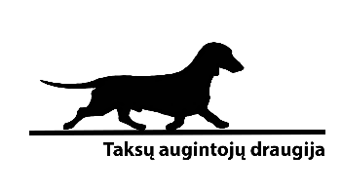

DACHSHUNDS OWNERS SOCIETY

ARTIFICIAL FOX DEN TRIAL
IN WHICH THE CACT IS COMNPETED
Date: 9th April, 2017
Trial venue: Radviliskis district, 55.776679, 23.695626 (55°46′36.0″N 23°41′44.2″E)
Judges: VALDAS PETRAUSKAS, AURIMAS LIBERIS, ARVYDAS ŠARKUS
(the society reserves the right to change judges if necessary)

Just entered in advance and included in the list of participants, at least 9 months of age or older FCI groups 3 and 4 dogs, having pedigrees accepted by FCI, can take part in the trial. Minimum number of participants is 6. Maximum number is 25.
The trial is organised according to the Society Artificial Fox Den Trial regulations announced in www.taksudraugija.lt.
Registration until 04-04-2017: for the Society members 18 €, for non-members of the Club 23 €, for foreign participants 30 €.
E-mail for registration show@taksudraugija.lt. To register your dogs the following documents must be sent:
1. Entry form;
2. Copy of pedigree;
3. Copy of LKD club member certificate (if you are a member of LKD club, but not the Club).
The time of trial starts will be announced two days before trial. Checking dogs, documents, registration and drawing lots to determine starting order begin at the place of trial at 30 min. before trial.
All participating dogs must be vaccinated against rabies. Period of time set by the manufacturer of the vaccine to acquire immunity must be finished according to law requirements of the Republic of Lithuania. Dogs participating in the trial must be identified with microchip (or a tattoo if it is made until 3rd July, 2011) and have pet passport.
Information is provided +370 656 05449, info@taksudraugija.lt.

